**ELEN 3374 Inverted Pendulum Final Project**

**Due: 5/4/2022 at 12pm**

**Description:**

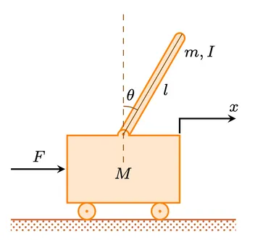The purpose of this project is to fully analysis a system using everything we have learned in class to control a pendulum to stay upright. An Inverted pendulum can be represented as a free body diagram in Figure 1. The inverted pendulum is an inherently a nonlinear system which means you will have to linearize the system. Develop a P, PI and PID controller to stabilize the system to remain upright. You have multiple team members meaning multiple students can we working together and separately on different task. The actual system is given to you in class.

Figure 1: Inverted Pendulum (FBD)

**Requirements:**

You are required to write a report, maximum of 15 pages with figures and equations. You must describe in detail your process with mathematical proofs, figures and textual explanation. The process should be as follow.

1. Write and research a nonlinear ODE that represents the system given in class.
2. Linearize the system into a linear state space representation around the required equilibrium point ( Stand up at a 90-degree angle or theta is 0)
3. Write the system as a transfer function.
4. Check for stability.
5. Determine the poles and response that you want to use and develop a controller. You can tune the controller with the Ziegler Nichols method.
6. Implement the controllers you have designed into the Inverted Pendulum.
   1. Fetch readings from Accelerometer
   2. Control Motor
7. Compare the results and your findings

**Resources:**

<https://www.youtube.com/watch?v=5qJY-ZaKSic&ab_channel=BriannoColler>

<https://ctms.engin.umich.edu/CTMS/index.php?example=InvertedPendulum&section=SystemModeling>

<https://en.wikipedia.org/wiki/Inverted_pendulum>